Question 1
Q. What is JSX in React.js? Why is it used?
Ans : JSX (JavaScript XML) In React.js Is A Syntax That Allows Us To Write HTML Inside JavaScript Code.
It Looks Like HTML, But It’s Actually JavaScript, And It Helps Create UI Elements In A Simple And Clear Way. JSX Makes The Code Easier To Read, Write, And Understand When Building React Components.
JSX Is Used In React.js Because It Makes Writing User Interfaces Easier And Clearer.
It Lets Developers Mix HTML With JavaScript, So They Can Create UI Elements In A Simple Way. JSX Also Helps Detect Errors Quickly And Makes The Code More Readable And Maintainable.

Question 2
Q. How is JSX different from regular JavaScript? Can you write JavaScript inside JSX?
Ans : JSX Is Different From Regular JavaScript Because It Looks Like HTML, But It's Written Inside JavaScript Files.
Yes, You Can Write JavaScript Inside JSX Using Curly Braces {}. This Lets You Add Dynamic Values, Functions, Or Expressions Within The HTML-Like Code.
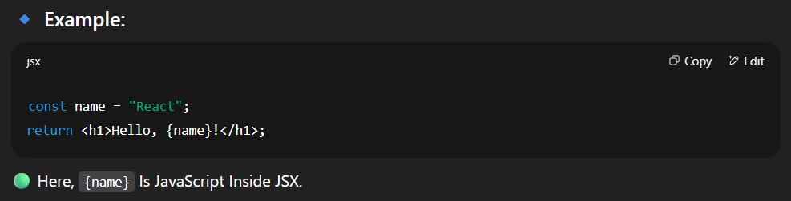
Question 3
Q. Discuss the importance of using curly braces {}in JSX expressions.
Ans :
In JSX, Curly Braces {} Are Very Important Because They Let Us Write JavaScript Expressions Inside HTML-Like Code.
This Means We Can Insert Dynamic Values, Variables, Functions, Or Even Conditional Logic Directly Into The UI. Without Curly Braces, JSX Would Only Show Plain Text.
